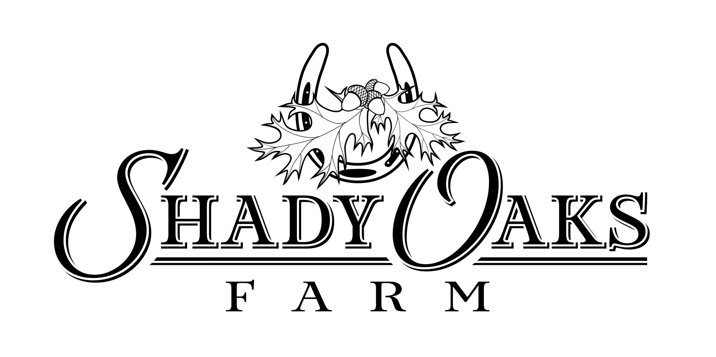
LIABILITY RELEASE

WARNING

Under Georgia law, an equine or animal activity sponsor or professional is not liable for injury to, or death of, a participant in equine or animal activities resulting from inherent risk of equine or animal activities pursuant to Chapter 12 of Title 4 to the Official Code of Georgia Annotated.

I have read and understand the Georgia Equine Liability Law. I shall hold Shady Oaks Horse Farm, LLC, its owners, trainers, employees, volunteers and tenants (specifically including William and Cheryl Drury and Sandra and Terry Pulliam, their successors, assigns and agents) harmless from any and all costs, claims, and liabilities of any kind arriving out of my use of the facility, any animal activities, any horse, pony, dog, cat, goat, or animal on the property, living at, visiting or boarding at the facility. As a consideration for my visiting the facility I assume any risk of damage to property, animal or injury to myself, or anyone visiting the facility with me. I understand horses can bite, kick, buck, etc., which can cause injury or death. I understand there are certain risks inherent with handling animals and I accept those risks.

Print Name: _____________________________________________________
Signature: ___________________________________Date: ______________
Address: _______________________________________________________
_______________________________________________________________
Emergency Contact Name: ________________________________________
Emergency Contact Phone: ________________________________________

Child(ren) who will accompany you:

Name: ___________________________________ Age: ________
Name: ___________________________________ Age: ________
Name: ___________________________________ Age: ________

Signature of Parent/Guardian for children under 18:

Occasionally we post pictures of our riders on websites such as Instagram, Facebook, or shadyoakseventing.com. By signing below, you acknowledge that we may post pictures of you or your child without prior written consent.

___________________________________________________________

