**Midnight Rose Equestrian LLC**

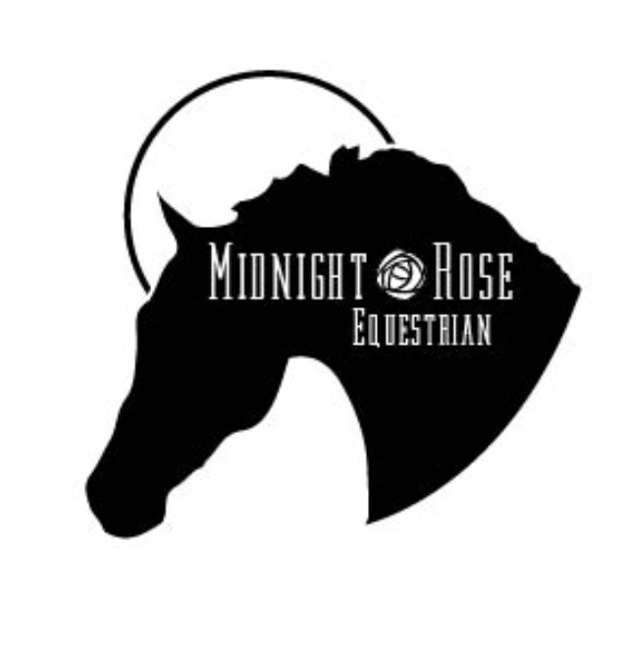

**Liability Release Form**

**RELEASE AND EXPRESS ASSUMPTION OF RISK AGREEMENT**

**NOTICE:  PLEASE READ THIS DOCUMENT CAREFULLY BEFORE SIGNING!**

This agreement is made this _____ day of __________________, ________ by and between Maria Ah Foon and Midnight Rose Equestrian LLC (hereinafter referred collectively as "Stables") and ________________________________________________(hereinafter referred to as "Participant");

WHEREAS, Participant desires to engage in horse-related activities on the premises known as Stables, activities including but are not limited to trail riding, lessons, training, working around horses, and being present on the premise as a guest or invitee of a Boarder, other Participant, Vendor or Stable; and WHEREAS, Stables desires to permit Participant to engage in the aforementioned activities on the premise of Stables in exchange for this Release Form. NOW, THEREFORE, in consideration for the permission from Stables to engage in horse related activities on its premises, Participant agrees as follows:

1. Participant agrees to abide by all instructions provided by Stables' employees, agents, servants, independent contractors, and representatives during each lesson and or/training session.

2. In the event Participant owns no tack or requires the use of tack owned by Stables, Participant acknowledges that the tack provided by Stables is in good repair and condition, and properly fitted to the horse on which the tack is to be used.

3. Participant agrees to wear a riding helmet (if under 18) and footwear with appropriate heels to ride.

4. Participant agrees that he/she is responsible for his/her own safety during lessons, training sessions, trail riding, and general exposure to horses, and understands that participation in horseback riding activities and training will expose him/her to above normal risks.

5. Participant agrees to provide his/her own insurance coverage for injury or damage to himself/herself, his/her horse, and personal property.

6. Participant acknowledges and understands the inherent risks associated in riding and working around horses, and participation in training sessions, which risks include, but are not limited to, bodily injury such as a result of using, riding, jumping, training, or being in close proximity to horses. Participant acknowledges and understands that personal injury, harm, or death may occur as a result of certain equine behaviors, including, but not limited to, biting; kicking; rearing; bucking; bolting; shying; falling; slipping; or stumbling; stepping on; balking at or refusing an obstacle; unpredictable reactions to drugs or medications; sounds; sudden emergencies; sudden movements; unfamiliar objects; persons or other animals, including dogs,; hazards of or on the land; motor vehicles; machinery; construction equipment and other motorized devices; collisions with other horses, livestock, trees, shrubberies, natural and man-made obstacles or objects.  Participant further acknowledges and understands that personal injury, harm or death may occur as a result of the inability of another person (other than Stables and its employees, agents, servants, or representatives) to fail to maintain control over a horse or to fail to act within that person's ability, or by some unforeseeable act of god.

7.  PARTICIPANT UNDERSTANDS, AGREES, AND EXPRESSLY ASSUMES ALL RISKS INVOLVED IN AND ARISING FROM PARTICIPATION IN HORSE-RELATED ACTIVITIES ON STABLES, INCLUDING BUT NOT LIMITED TO THE RISK OF DEATH, BODILY INJURY, AND PROPERTY DAMAGE TO PARTICIPANT AND HER/HER HORSE, WHICH MAY RESULT FROM ANY HAZARD, INCLUDING BUT NOT LIMITED TO THOSE SET IN PARAGRAPH 8 ABOVE, AND INCLUDING, THE NEGLIGENCE AND/OR DELIBERATE ACT OF ANY OTHER PERSON.

8.  PARTICIPANT AGREES THAT HE/SHE SHALL HOLD HARMLESS AND RELEASE STABLES, MARIA AH FOON AND MIDNIGHT ROSE EQUESTRIAN LLC, THEIR EMPLOYEES, AGENTS, SERVANTS, INDEPENDENT CONTRACTORS AND REPRESENTATIVES, FROM ANY AND ALL LIABILITY WHATSOEVER, EXCEPT IF THE DAMAGES OR INJURIES COMPLAINED OF ARE CAUSED BY THE DIRECT, WILLFUL, WANTON AND GROSS NEGLIGENCE OF STABLES.Â  PARTICIPANT FURTHER AGREES THAT HE/SHE WILL NOT INSTITUTE ANY LEGAL ACTION AGAINST STABLES, MARIA AH FOON AND MIDNIGHT ROSE EQUESTRIAN LLC, THEIR EMPLOYEES, AGENTS, SERVANTS, INDEPENDENT CONTRACTORS, AND REPRESENTATIVES ON ACCOUNT OF OR IN CONNECTION WITH ANY CLAIMS, CAUSES OF ACTION, INJURIES, DAMAGES, COSTS OR EXPENSES ARISING AS A RESULT OF PARTICIPANT'S PARTICIPATION IN HORSE-RELATED ACTIVITIES AT STABLES, AND USE OF OR PRESENCE ON PROPERTY ON OR LEASED BY STABLES, INCLUDING WITHOUT LIMITATION, THOSE CAUSES OF ACTION OR INJURIES COMPLAINED OF ARE CAUSED BY THE DIRECT, WILLFUL, WANTON, AND GROSS NEGLIGENCE OF STABLES, MARIA AH FOON AND MIDNIGHT ROSE EQUESTRIAN LLC, THEIR EMPLOYEES, AGENTS, SERVANTS, INDEPENDENT CONTRACTORS AND REPRESENTATIVES AGAINST ANY AND ALL CLAIMS, CAUSES OF ACTION, DAMAGES, JUDGEMENTS, COSTS OR EXPENSES, INCLUDING ATTORNEY'S FEES, WHICH IN ANY WAY ARISES AS A RESULT OF THE PARTICIPANT'S PARTICIPATION IN HORSE-RELATED ACTIVITES AT STABLES, AND THE USE OF OR PRESENCE UPON PROPERTIES OWNED, OCCUPIED OR UTILIZED BY STABLE.

9.  Participant waives the protection of any statute in any jurisdiction, the purpose, substance and/or effect of which is to provide that a general release shall not extend to claims, material or otherwise, which the person executing the release does not know or suspect to exist at the time of the execution of the release.

**I/WE HAVE READ THE ABOVE, UNDERSTAND THE SAME, AND AGREE TO BE LEGALLY BOUND BY ALL THE TERMS OF THIS RELEASE AGREEMENT.**

**PARTICIPANT**

**___________________________________________________**

Sign and date

**PARENT or GUARDIAN (if under 18yrs. of age)**

**____________________________________________________**

Sign and date

**MARIA AH FOON**

_____________________________________________________

Sign and date