**Dressage at the Bucks County Horse Park (I, II, III, and IV)**

*2024 GAIG/USDF Regional Dressage Championship Qualifying*

*2024 Col. Bengt Lungquist Memorial (CBLM) Championship Qualifying*

**Dressage at the Park Fall Festival**

*2025 GAIG/USDF Regional Dressage Championship Qualifying*

*2025 Col. Bengt Lungquist Memorial (CBLM) Championship Qualifying*

|  |  |  |  |  |  |  |
| --- | --- | --- | --- | --- | --- | --- |
| Date | License # | USEF Level | Judges | TD | Open | Close |
| May 5 | 316990 | 2 | Heather Mason, S  Jean Thornton, R | Michelle King | March 15 | April 29 |
| June 2 | 316992 | 1 | Lori Barnard, S  Lauren Annett, r | Anita Jaffe | March 15 | May 27 |
| July 13 | 322602 | 1 | Heather Mason, S*  *\*FEI Classes only*  Angela Voss, R  Torrey Wilkinson, r | Carol Lippa | March 15 | July 10 |
| August 4 | 316994 | 1 | Kem Barbosa, S  Anne Moss, R | Elizabeth Doering | March 15 | July 29 |
| October 20 | 344912 | 2 | Barbara Ebner, S  Susan Jones Sinelnik, r | Joan Fleser | March 15 | October 14 |

Show Manager/Secretary:

Maureen Ferris, BCHP Administrator For more information and prizelist updates, go to:

PO Box 386 [www.buckscountyhorsepark.org](http://www.buckscountyhorsepark.org)

Revere, PA 18953

Directions: Bucks County Horse Park is located on Route 611, ½ mile north of Revere, PA. Trailers from New Jersey must come over the Milford bridge, Route 78 to the Hellertown exit, or Route 22 to the 611 South exit. TRAILERS MAY NOT CROSS AT RIEGLESVILLE.

***New for 2024!!***

***Series awards will be presented at the***

***Dressage at the Park***

***Fall Festival***

***October 20, 2024***

Qualifications/Rules:

* Horse/Rider combinations must compete at the Fall Festival and at least one additional BCHP USDF/USEF show during 2024.
* The top 3 scores for Fourth level and below, and the top 2 scores for FEI, will be averaged to determine placings.
* Horse/Rider combinations must be the same for all scores to count for each award. Riders and horses may be part of more than one competing combination.
* Scores must be acquired across no more than two levels (i.e. Training and First, but not First and Third).
* Riders should declare their intention to participate by signing up with the secretary at any show before the Fall Festival.
* Horse/rider combinations will be split into Section A and Section B for the purposes of series awards. Riders in Section A may not have competed more than two levels above at any point at a USDF show in this or prior years. Riders who have competed more than two levels above will be placed in Section B.

Awards:

* Champion, Reserve, and 3rd through 6th place will be awarded for each division at each level – Training, First, Second, Third, Fourth, and FEI. For any atypical tests, the USDF equivalency may be used.

|  |  |  |  |  |
| --- | --- | --- | --- | --- |
| Class | Class Description | Divisions | Fee | Qualifying Fees |
| 100 | USDF Introductory Test A | O | 45 | n/a |
| 200 | USDF Introductory Test B | O | 45 | n/a |
| 300 | USDF Introductory Test C | O | 45 | n/a |
| 101 | Opportunity Class – Training Test 1 | O | 45 | n/a |
| 102 | Opportunity Class – Training Test 2 | O | 45 | n/a |
| 103 | Opportunity Class – Training Test 3 | O | 45 | n/a |
| 201 | Opportunity Class – 1st Test 1 | O | 45 | n/a |
| 202 | Opportunity Class – 1st Test 2 | O | 45 | n/a |
| 203 | Opportunity Class – 1st Test 3 | O | 45 | n/a |
|  |  |  |  |  |
| 1 | Training Level Test 1 | O, AA, Jr/YR | 45 |  |
| 2 | Training Level Test 2 | O, AA, Jr/YR | 45 | BLM (N/C) |
| 3 | Training Level Test 3 | O, AA, Jr/YR | 45 | GAIG +15 |
| 11 | First Level Test 1 | O, AA, Jr/YR | 45 |  |
| 12 | First Level Test 2 | O, AA, Jr/YR | 45 | BLM (N/C) |
| 13 | First Level Test 3 | O, AA, Jr/YR | 45 | GAIG +15 |
| 21 | Second Level Test 1 | O, AA, Jr/YR | 45 |  |
| 22 | Second Level Test 2 | O, AA, Jr/YR | 45 | BLM (N/C) |
| 23 | Second Level Test 3 | O, AA, Jr/YR | 45 | GAIG +15 |
| 31 | Third Level Test 1 | O, AA, Jr/YR | 45 |  |
| 32 | Third Level Test 2 | O, AA, Jr/YR | 45 | BLM (N/C) |
| 33 | Third Level Test 3 | O, AA, Jr/YR | 45 | GAIG +15 |
| 41 | Fourth Level Test 1 | O, AA, Jr/YR | 45 |  |
| 42 | Fourth Level Test 2 | O, AA, Jr/YR | 45 | BLM (N/C) |
| 43 | Fourth Level Test 3 | O, AA, Jr/YR | 45 | GAIG +15 |
| 60 | USDF MFS Training – 4th level TOC | O, AA, Jr/YR | 55 | GAIG +15, BLM (N/C) |
| 61 | USDF TOC Training – 4th level | O, AA, Jr/YR | 45 | GAIG +15, BLM (N/C) |
| 62 | USEF 4 Year Old Test | Open | 55 |  |
|  |  |  |  |  |
| 50 | FEI Prix St. Georges | O, AA, Jr/YR | 55 | GAIG +15, BLM (N/C) |
| 51 | FEI Intermediate 1 | O, AA, Jr/YR | 55 | GAIG +15, BLM (N/C) |
| 52 | FEI Intermediate 2 | O, AA, Jr/YR | 55 | GAIG +15, BLM (N/C) |
| 53 | FEI Grand Prix | O, AA, Jr/YR | 55 | GAIG +15, BLM (N/C) |
| 54 | FEI TOC | O, AA, Jr/YR | 55 | GAIG +15, BLM (N/C) |
| 55 | FEI Musical Freestyle TOC | O, AA, Jr/YR | 55 | GAIG +15, BLM (N/C) |
| 58 | FEI Para Dressage TOC | Open | 55 |  |
| 59 | FEI 5 Year Old Test/6 Year Old Test | Open | 55 |  |
|  |  |  |  |  |
| 75 | Dressage Seat Equitation | JR/YR | 55 | **May 5 and June 2 only** |

Please state on entry whether riding Open/Adult Amateur/Junior/Young Rider status. GAIG qualifying riders please indicate status and include an additional $15 fee. EVERY CLASS OFFERED HEREIN WHICH IS COVERED BY THE RULES AND SPECIFICATIONS OF THE CURRENT USEF RULEBOOK WILL BE CONDUCTED AND JUDGED IN ACCORDANCE THEREWITH.

**GAIG Qualifying fee increases to $20 for the 2025 competition year, Fall Festival competitors will be responsible for the $20 fee.

Entry Fees – make check payable to BCHP

**REQUIRED FEES** – ALL entries should include these fees

Class Fees:

Intro, Opportunity, Training $45

First through Fourth $45

FEI Level Classes $55

Musical Freestyles $55

Specialty classes refer to class list

Federation Fee: $23 per horse

Office Fee: (non-refundable) $35 per entry

ADDITONAL FEES:

GAIG/USDF Qualifying – additional/class $15/class**

Late Entry fee $30

Class change fee $10

Secretary Verification Fee (all incomplete entries charged) $15

**\*\*GAIG Qualifying fee increases to $20 and USDF Non-member fee increases to $55 for the 2025 competition year, Fall Festival competitors will be responsible for the increased fees.**

ENTRIES: Mail entries to secretary or enter online via https://bluehorseentries.com/discover. Make checks payable to BCHP. Entries and payment must be received by the closing date or $30 late fee is applied. **$15 Fee for Incomplete Entries.** For special deliveries, please send entries without a signature needed! No verified, registered or express mail requiring signature will be accepted. Illegible or incomplete entries may be returned. All entries must be typed or printed on the official USEF/USDF entry form. Late entries accepted until Wednesday prior to show if scheduling allows.

**Refund Policy**: Cancellations prior to the closing date will be refunded less office fee. **No refunds** will be given after closing date without a medical excuse.

**Complete entries must include:**

-Original handwritten signatures (owner, rider, trainer, and coach, if applicable.)

-Proof of negative coggins within 12 months and proof of required vaccinations within 180 days of show date.

-Copies of USEF membership or ID cards for each owner, rider, trainer, coach or a non-member fee. Copies of USDF membership for owner and rider.

-Copy of the USDF horse’s ID registration/recording card.

-GAIG classes require Horse USDF Lifetime Registration and USEF Annual or Lifetime Recorded. Riders must have a USDF Participating Membership and a USEF Junior Active, Senior Active or Life Membership. Owners must have a USDF Participating or Business Membership and a USEF Junior Active, Senior Active or Life Membership.

*(Go to* [*www.eqverification*](http://www.eqverification) *and print all your membership cards on one sheet).*

-Emergency number must be included.

-Updated USEF Entry Agreement and Release must be signed. (2 documents)

-A $15 fee will be assessed for secretary verification of missing or incorrect information.

**Reminder: All USEF Life and Senior Active members, as well as participants who have regular contact with minor athletes, are required to comply with the U.S. Center for SafeSport training requirement to be eligible to participate in the competition. All participants must adhere to the U.S. Center for SafeSport Code, USEF Safe Sport Policy, and the Minor Athlete Abuse Prevention Policies. More information about these can be found at** [**www.usef.org**](https://na01.safelinks.protection.outlook.com/?url=http%3A%2F%2Fwww.usef.org%2F&data=04%7C01%7C%7C85935439a5e64d0e338f08d8fdf4d0e5%7C84df9e7fe9f640afb435aaaaaaaaaaaa%7C1%7C0%7C637538576311220141%7CUnknown%7CTWFpbGZsb3d8eyJWIjoiMC4wLjAwMDAiLCJQIjoiV2luMzIiLCJBTiI6Ik1haWwiLCJXVCI6Mn0%3D%7C1000&sdata=FgHD%2FMMtuu0K5YD5p3fseaGz1l%2F3Vcu24twD073ZVns%3D&reserved=0)**. Training must be completed within one year of the show date for all senior riders, owners, trainers, and coaches.**

**Official Ride Times**: Classes may not necessarily run in the order listed in the prizelist. It is the responsibility of the rider to inform the show secretary of any time conflicts as soon as possible after receiving the schedule. Management reserves the right to change officials, limit entries, combine or cancel classes, modify the schedule, modify or cancel awards and/or whatever changes are required by circumstances to the competition specifications. Provisional times will be available to competitors at [www.startboxscoring.com](https://www.startboxscoring.com/showcalendar.php). Official times will be available at noon the day before the show. All change requests must be made in writing by 10:00AM the two days prior to the show. All no-shows will be scratched from their subsequent tests.

**Hazardous Weather/Act of God/ Accident Policy**: Management reserves the right to cancel any classes due to hazardous weather, Acts of God, accident or emergency. Every effort will be made to reschedule with priority given to any qualifying classes being offered. No refunds for cancellations due to hazardous weather, Acts of God, accidents or emergencies.

**Scores**: It is the responsibility of the competitor to verify the accuracy of all scores. Scoring errors must be reported to the Show Secretary within one hour of the official posting of the scores from the last class of the show day during which the score was earned.

**Awards**: 1st through 6th ribbons awarded in each class with 3 or more entries. Division Level Champion and Reserve Champion ribbon and award will be given.

**Concessions**: Bottled water will be available at all shows. Competitors will be notified regarding the availability of additional concessions prior to the show.

**Dogs**: Well-mannered dogs on leashes no longer than 6 feet are allowed. Pennsylvania leash law will be enforced.

**Lodging**: Holiday Inn Express, Hellertown, PA.; Hampton Inn, Doylestown, PA (215)343-8400; Econolodge, Quakertown, PA.

**Professional Services**: Contact numbers will be posted the day of the show. An EMT will be on grounds. Vet will be on call. Quakertown Veterinary Clinic. 215-536-2726. Farrier services will be call.

**Opportunity Classes/Intro Tests**: Opportunity classes are intended for entry level riders. Horses and riders entered only in “Opportunity” classes and Introductory tests are exempt from USEF and USDF membership requirements, and do not have to pay non-members (Show Pass) or HID fees. Federation and drug fees do not apply. Horses entered only in these classes are still subject to and must comply with the Drugs and Medications rules and are subject to drug testing. Participants must abide by all USEF regulations to attire, tack, and equipment for the recognized show. Reference GR821 for additional information. Riders and horses entered in these classes are subject to USEF gait requirements, judging criteria, and dress/tack regulations. Riders and horses may cross enter into additional rated/recognized classes (membership requirements apply).

**Freestyles/Music**: Competitors must submit a copy of a test at the level showing that the required score was met to enter the Freestyle at the level. Music for all freestyles on CD must be given to show office upon check in. It is the responsibility of the competitor, if requested, to supply the management with a sound person to run the music. Sound checks will be done on breaks prior to scheduled times.

**Stabling**: Two 11’ x 11’ day stalls, with solid ½ doors are available on the show grounds. Please note stabling requests on entry form. No guarantees.

**Arenas/Footing/Warm-Up**: All tests and warm-up will be ridden in sand/blue stone mix. One competition ring has a sand/rubber mix. Competition arenas include up to three arenas. Competition arenas will be 20 meters x 60 meters. Lunging Area/Alternate warm-up also available with sand/blue stone mix.

**Sharps Containers**: Show management will provide one sharps container per 50 stabled horses, per USEF rule 1211.5. Competition Management may fine any individuals including trainers, owners, exhibitors, or their agents up to $100 for improper disposal of needles or other sharp disposable instruments.

USEF rules go into effect upon arrival at the show grounds. Per DR120.1-6 **PROTECTIVE HEADGEAR MUST BE WORN AT ALL TIMES WHEN MOUNTED** (exception for FEI competitors exempted by FEI rules. It is recommended that ALL competitors wear protective headgear, see Article 427)! **Bridle numbers must be worn at all times when a horse is out of stall or trailer.** Riders participating in Level 1 competitions or in Opportunity classes are not required to wear a jacket.

**HOLD HARMLESS CLAUSE**: Understanding that horse sports may be hazardous and dangerous, even leading to permanent injury or death, each owner, rider, spectator, and other participant assumes any and all risk of loss or injury and agrees to hold harmless, regardless of negligent acts or omissions the Bucks County Horse Park, the show management, show committee, and all horse show personnel. **YOU ASSUME THE RISK OF EQUINE ACTIVITIES PURSUANT TO PENNSYLVANIA LAW.**

**USEF MEMBERSHIP STATEMENT**

Life, senior active and junior active members shall be eligible to participate in all classes at Regular Competitions, Eventing Competitions at the Modified Level or above and Combined Driving Competitions at the Advanced Level, Dressage, Reining and Vaulting Competitions and Endurance Rides. A non-member may participate as a handler, rider, driver, owner, lessee, or agent at Regular Competitions, Eventing Competitions, Dressage Competitions, Reining Competitions and Combined Driving Competitions upon payment of a Show Pass fee. Participants in the following classes are exempted from the Requirements of this rule: 1) leadline; 2) exhibitions; 3) games and races; 4) classes for 4-H members; 5) walk trot and academy classes (academy classes are classes limited to horses used regularly in a lesson program); 6) USDF introductory level tests, pas de deux and quadrille classes; 7) assistant handlers in Dressage Sport Horse Breeding classes

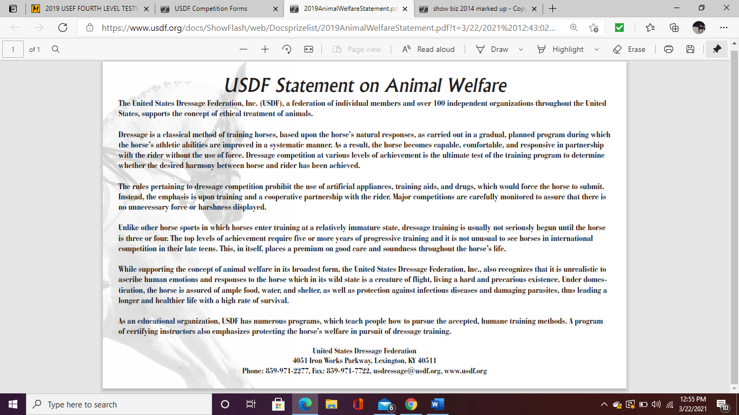

**USEF Motor Vehicle Statement:** Minors who do not have a valid driver’s license which allows them to operate a motorized vehicle in the state in which they reside will not be permitted to operate a motorized vehicle of any kind, including, but not limited to, golf carts, motorcycles, scooters, or farm utility vehicles, on the competition grounds of licensed competitions. Minors who have a valid temporary license may operate the above described motorized vehicles as long as they are accompanied by an adult with a valid driver’s license. The parent/legal guardian or individual who signs the entry blank as a parent or guardian of a minor operating a motorized vehicle in violation of this rule are solely responsible for any damages, claims, losses or actions resulting from that operation. Violations of this rule will be cause for penalties against those responsible for the child committing the offense. Wheelchairs and other mobility assistance devices for individuals with disabilities are exempt from this rule. The unsafe use of personal electronic transport devices, as determined by the competition officials and management in their sole discretion, that do not require a driver’s license to operate, including but not limited to segways, hover boards, and single wheeled scooters is prohibited on competition grounds. Operating such devices in areas where people gather may be deemed “unsafe use” if there is a risk of harm to others. If the operator of the device is a minor, the parent/legal guardian or individual who signs the entry blank as a parent or guardian of a minor operating the device in violation of this rule is accountable and may be subject to penalties. Wheelchairs and other mobility assistance devices for individuals with disabilities are exempt from this rule.

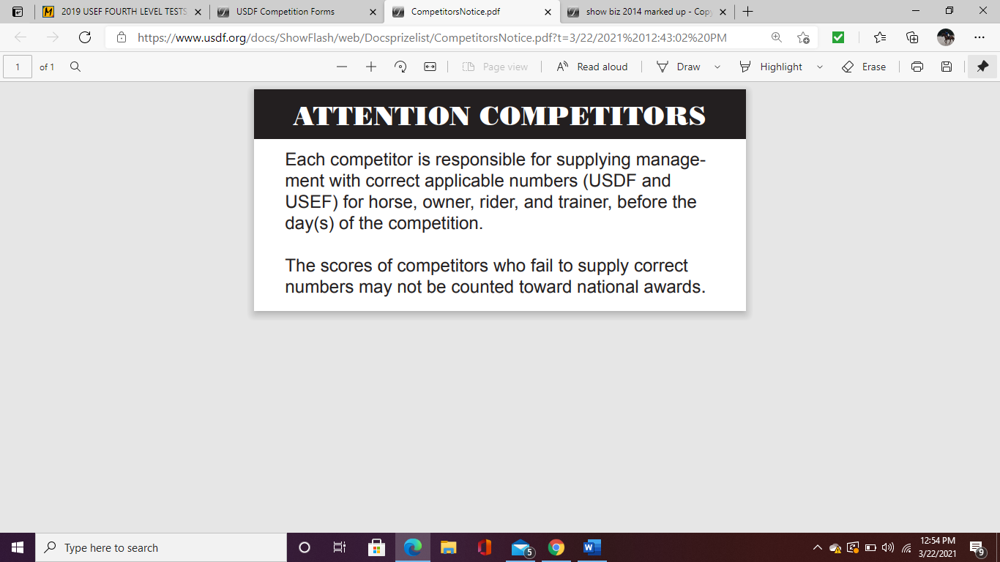

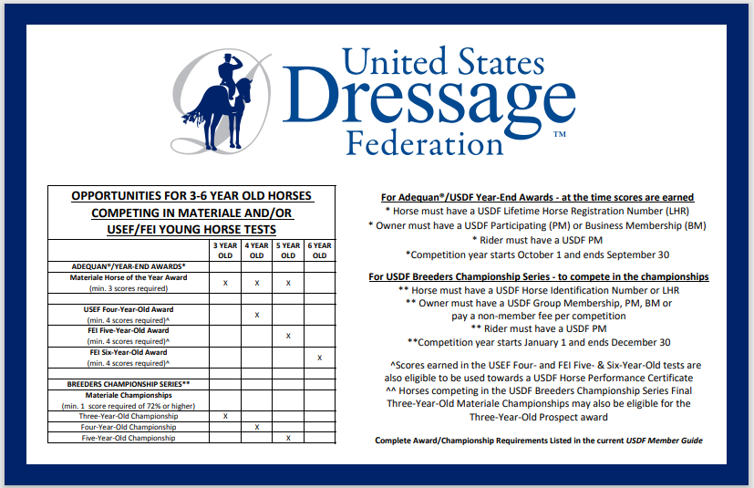

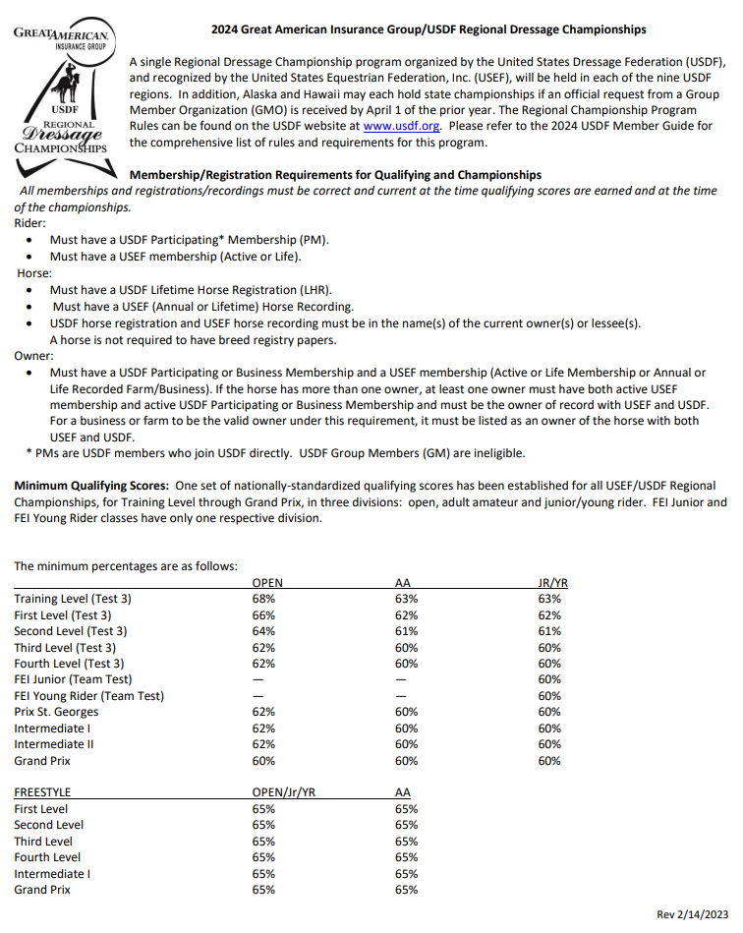

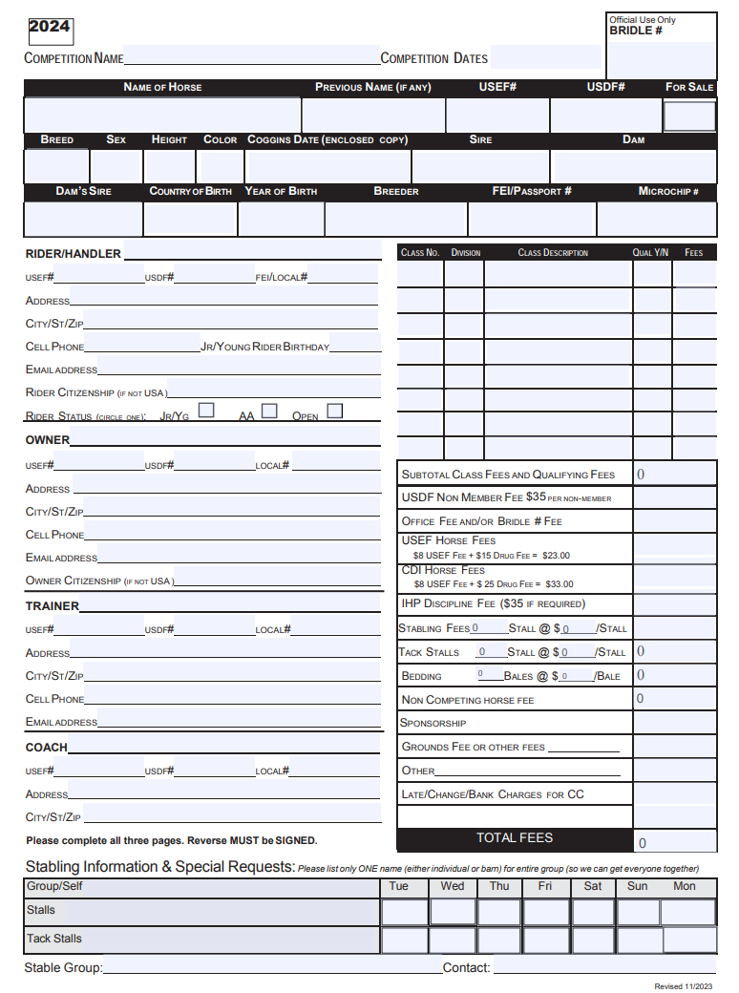

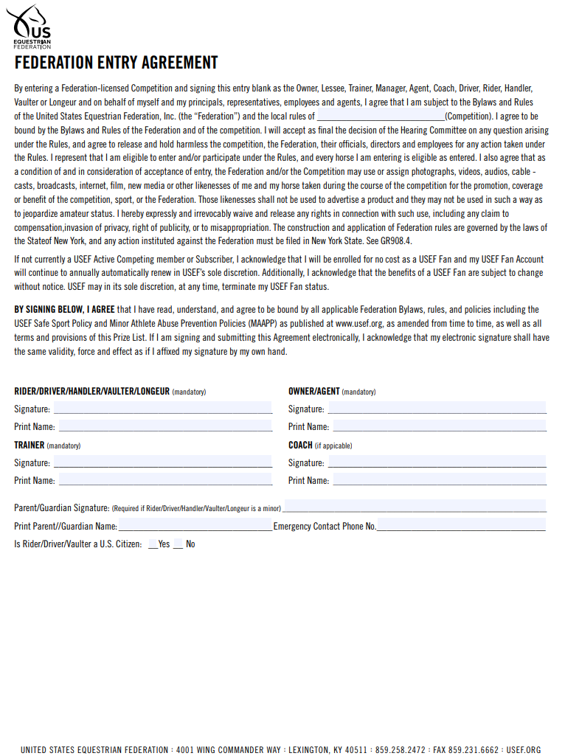

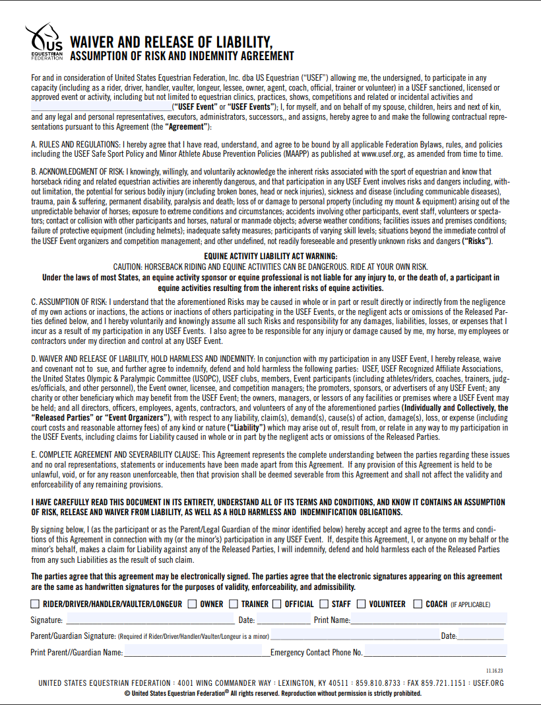

Dressage at the Bucks County Horse Park

USDF Dressage, Level 1/2 License Numbers: 316990, 316992, 322602, 316994, 344912